
MATHS METHODS (CAS) 3 & 4
TRIAL EXAMINATION 1
SOLUTIONS
2013

___________________________________________________________________________
Question 1 (3 marks)

- 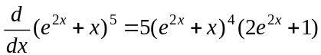
(1 mark)

This question is done using the chain rule, the quick way. That is, bring the power (5) to the front and reduce the power by one to 4. Then multiply by the derivative of what is in the brackets.

- 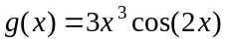
(1 mark)
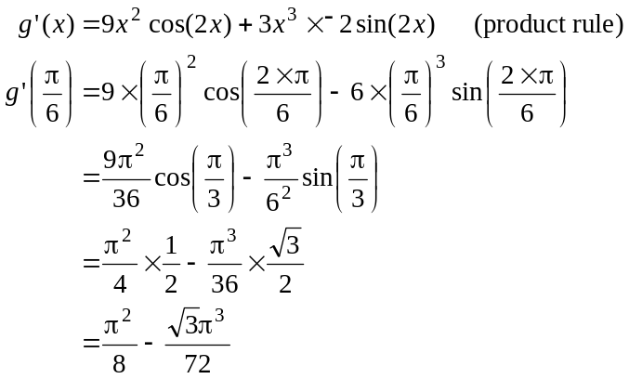
(1 mark)

Question 2 (2 marks)

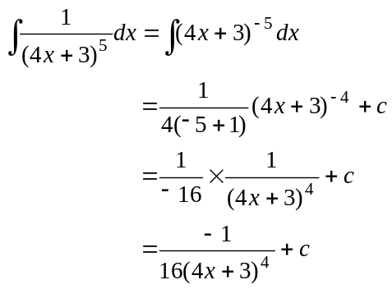
(1 mark)
(1 mark)

Question 3 (4 marks)

- Let 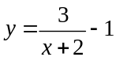
Swap x and y for inverse.
(1 mark)
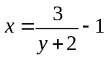
Rearrange
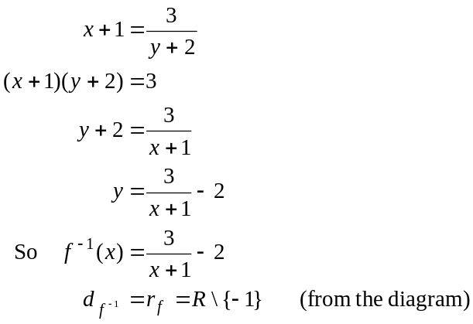
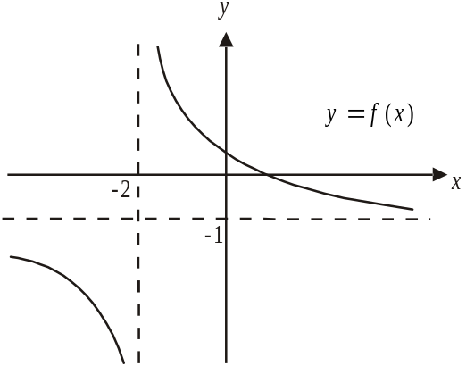

Alternatively, 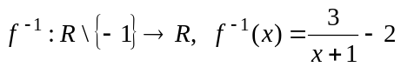
(1 mark) correct rule
(1 mark) correct domain

- 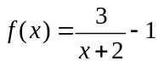

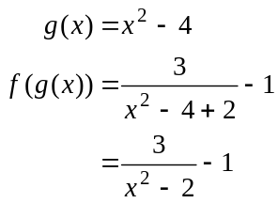
(1 mark)
Question 4 (5 marks)
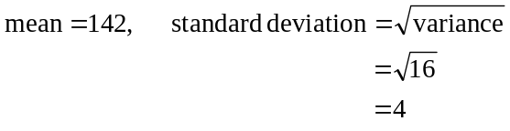

We’re given that 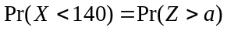.
Start by finding the corresponding value of z when 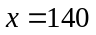.
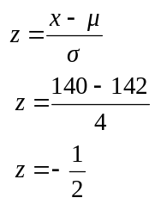
(1 mark)
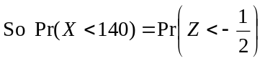

Now, from the diagram, and using the
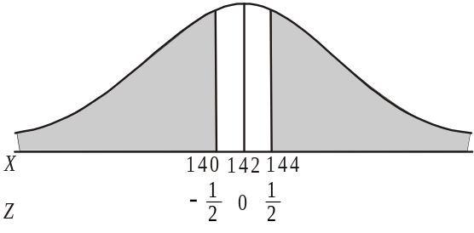
symmetry of the normal curve,

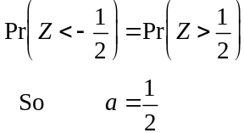
(1 mark)

- i. Using the diagram from part a.,
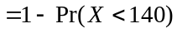
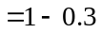
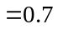
(1 mark)

ii. This is a conditional probability question.
Method 1 – intuitively
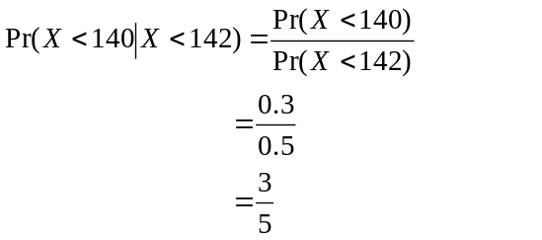
(1 mark)
(1 mark)
Method 2 – using the formula
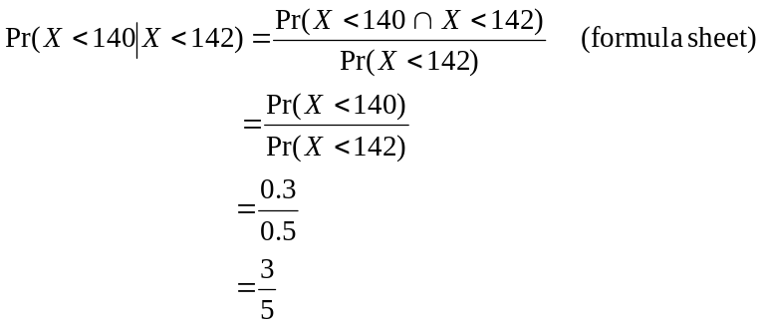
(1 mark)
(1 mark)
Question 5 (4 marks)

- 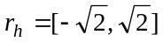
(1 mark)
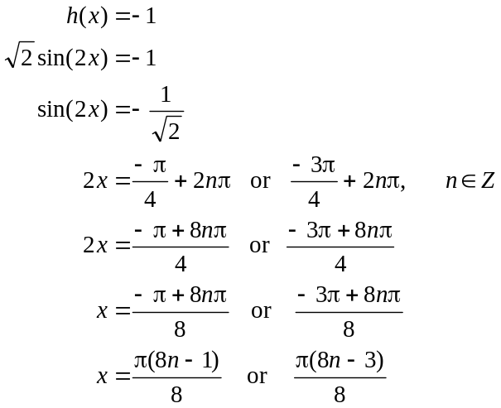

(1 mark)

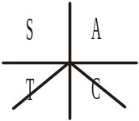

(1 mark) (1 mark)

Alternatively,
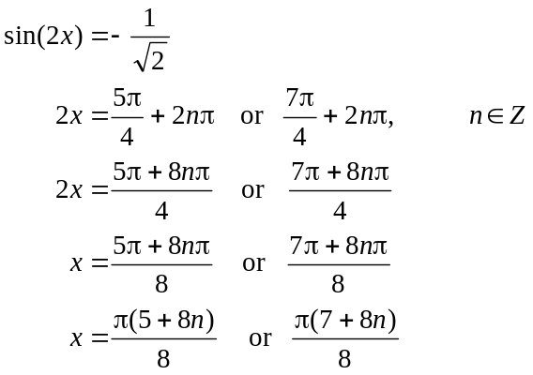
(1 mark) (1 mark)

Question 6 (3 marks)

Since f is a probability density function,
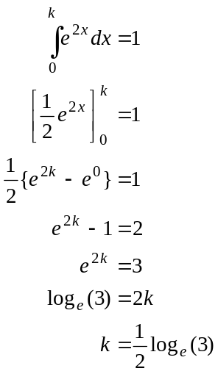
(1 mark)
(1 mark)
(1 mark)
Question 7 (4 marks)

- 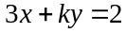
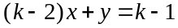

The corresponding matrix equation is
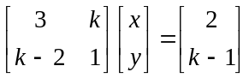

If 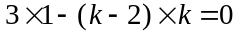 there are infinite solutions or no solution.
(1 mark)
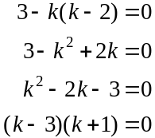
(1 mark)
If ,
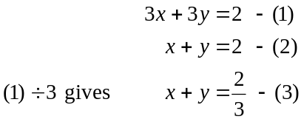
Since (2) and (3) describe parallel lines, there are no solutions for .

If ,
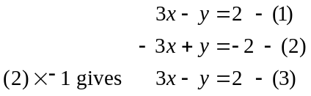
Since (1) and (3) are the same line, there are infinite solutions for .

So for no solutions .
(1 mark)

- For 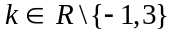 there exists a unique solution.
(1 mark)
Question 8 (4 marks)

- The graphs intersect when
(1 mark)
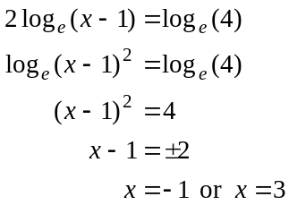
Since 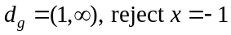.
(1 mark)
So the x-coordinate of the point of intersection is .

- i. 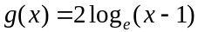
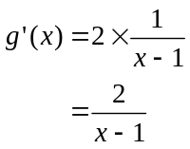
(1 mark)
- Since 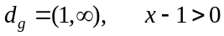,
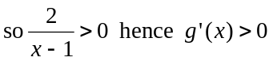 as required.
(1 mark)

Question 9 (4 marks)

Do a quick sketch.
(1 mark) – correct terminals
(1 mark) – correct integrand
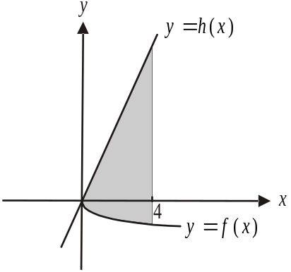
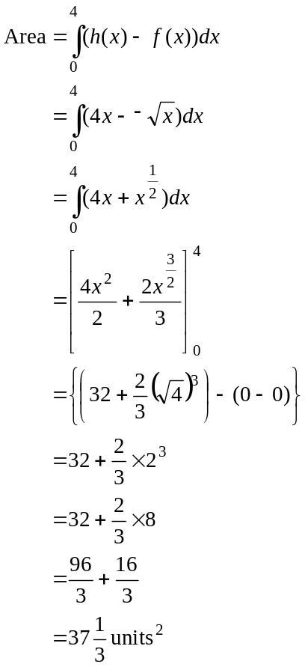
(1 mark)
(1 mark)
Question 10 (7 marks)

- i. 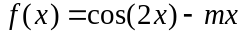
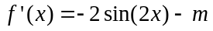 (1 mark)

  - Stationary points occur when 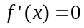; that is, when
(1 mark)
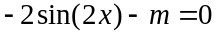
When 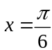, we have
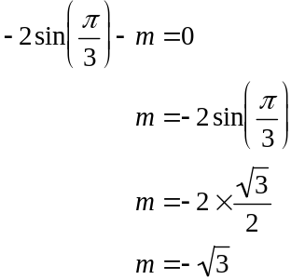
(1 mark)
- from part a. i.
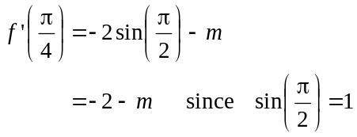
(1 mark)
So the gradient of the tangent is .

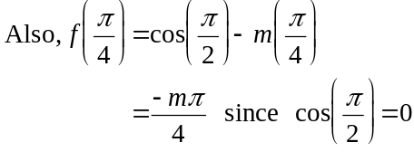
So the gradient passes through the point 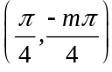.
(1 mark)
Equation of tangent given by
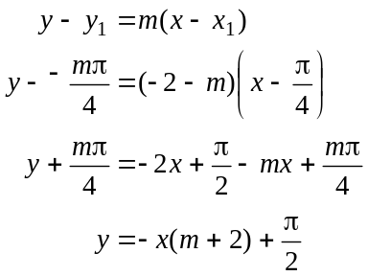
(1 mark)
- Substitute 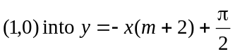
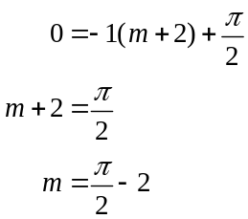
(1 mark)

